Heritage Group Sales
Christmas is coming!

NEW Christmas Card for 2017  A seasonal reproduction of a classic view of a NWNGR excursion train leaving Dinas.  A5 size card, edge folded.  £7.50 per pack of 5 | 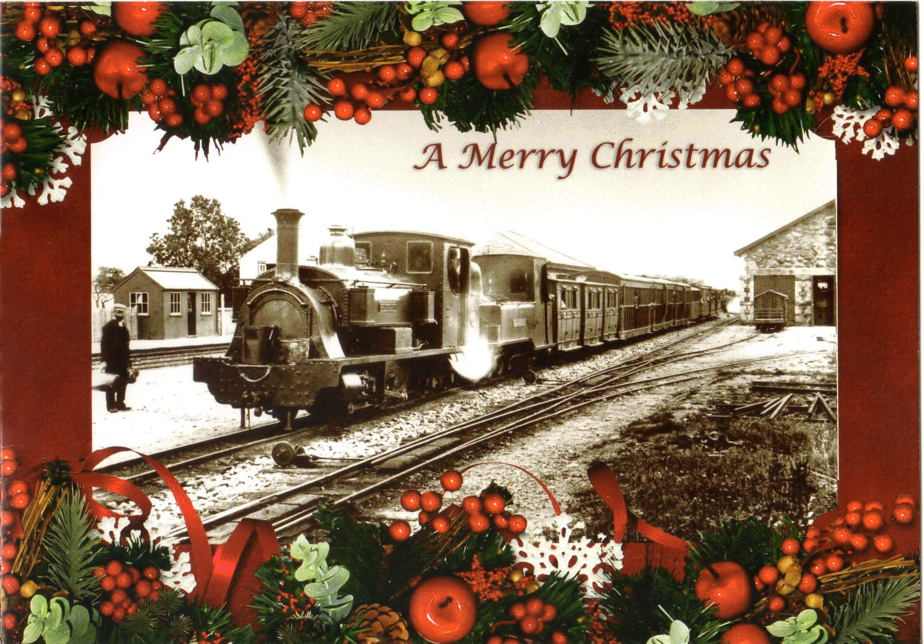
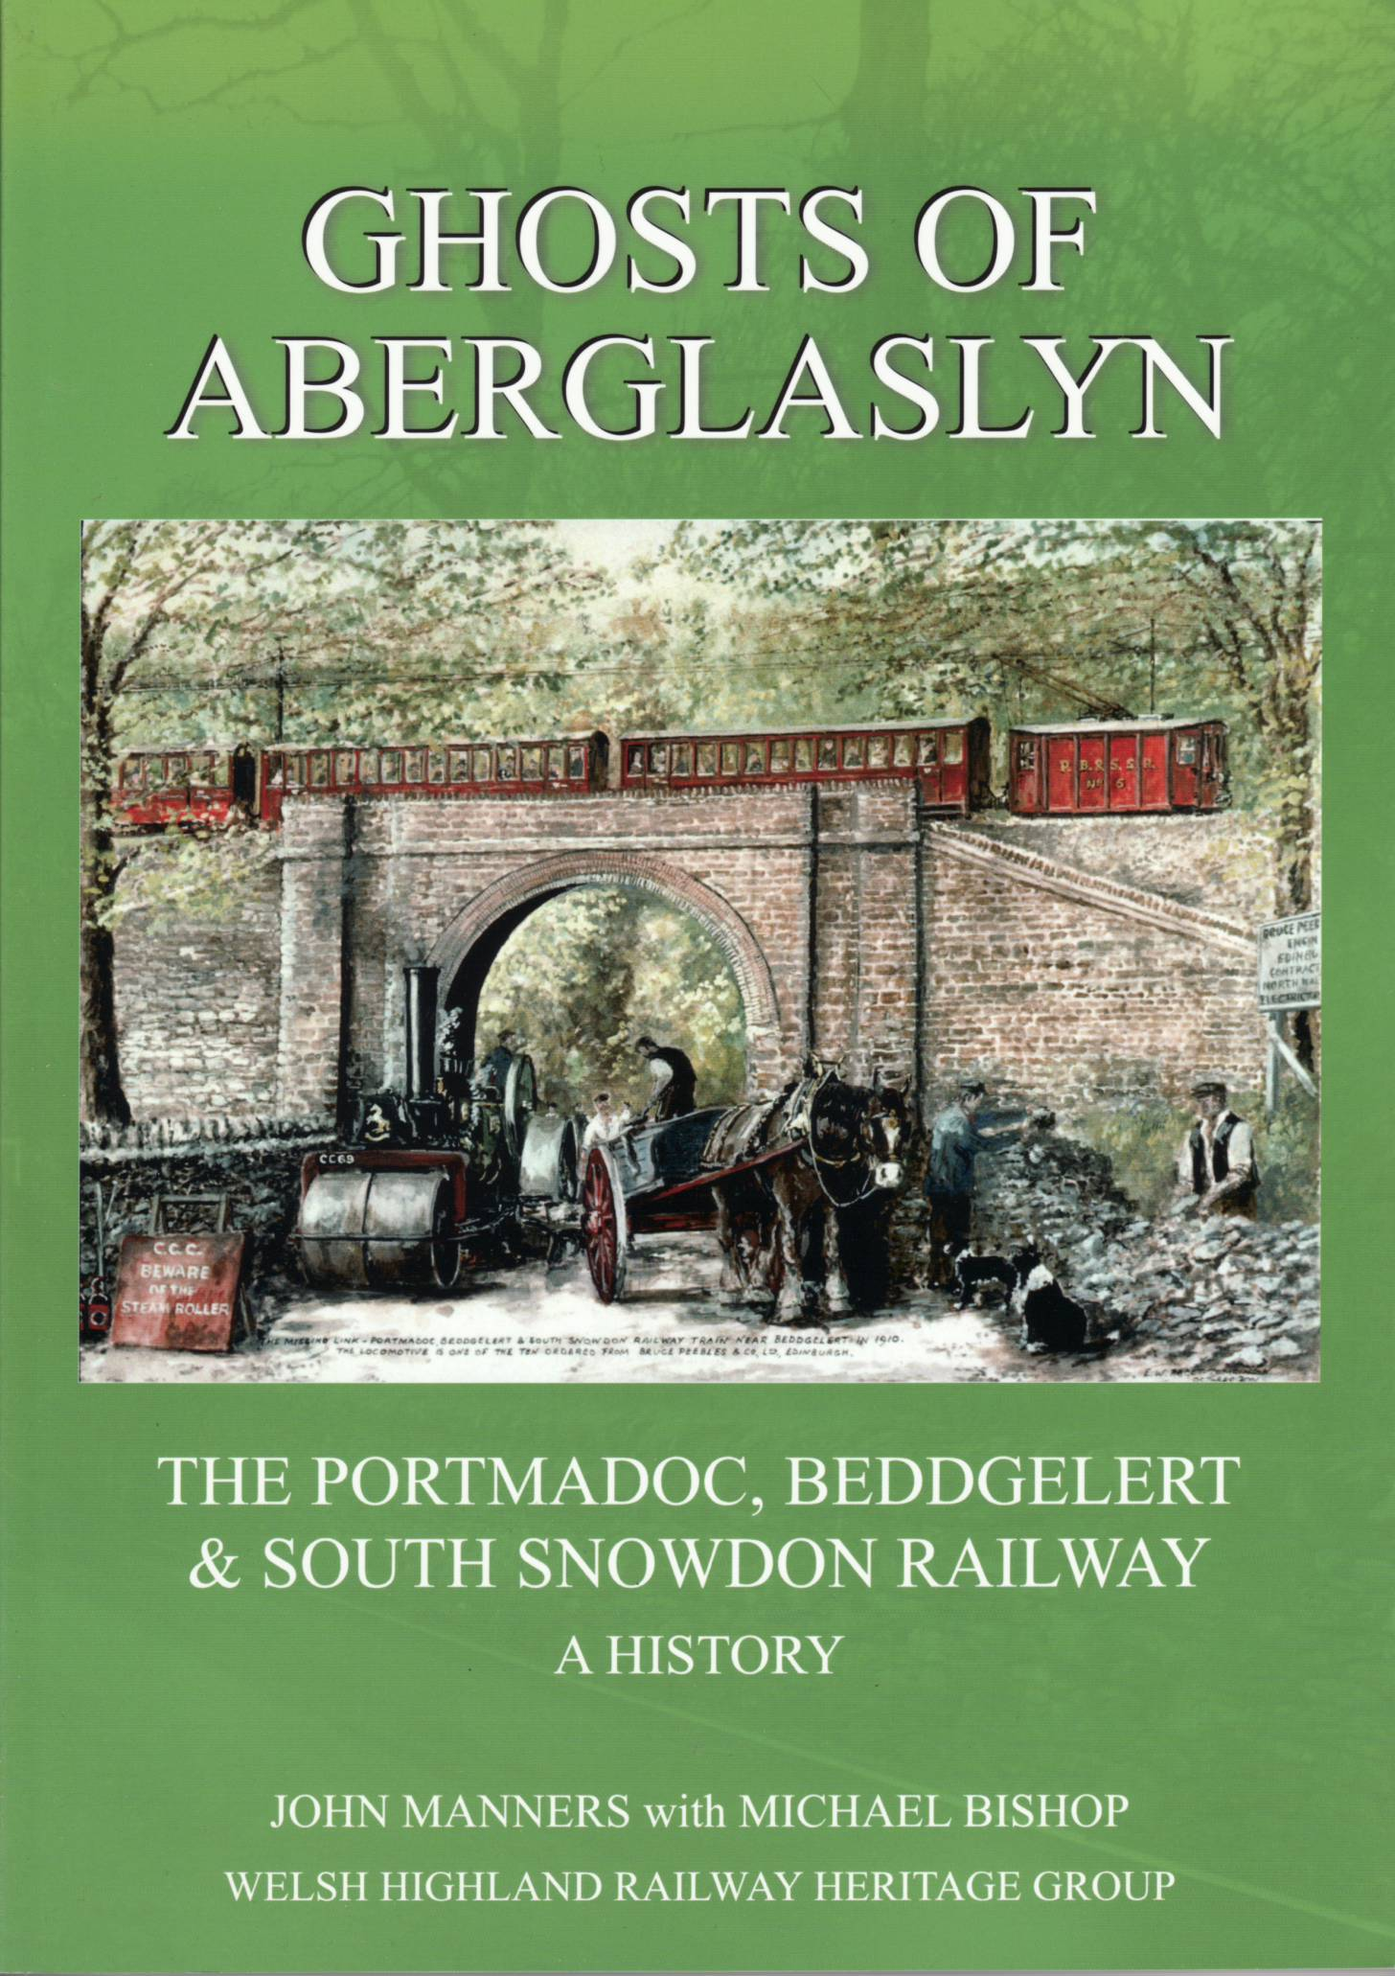 | Ghosts of Aberglaslyn  Fewer than 100 copies of John Manners’ account of the Portmadoc, Beddgelert & South Snowdon Railway remain in stock. There will be no reprint, so buy now to avoid disappointment.  £18.00
The Bryngwyn Branch  The history of the NWNGR’s principal source of traffic, presented by Dave Southern & John Keylock with extensive photographic content.  £15.00 | 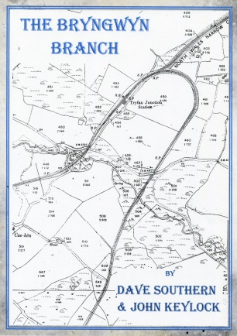
The Buffet Car  Redesigned and updated  with new information, including the completed restoration, this second edition is just  £15.00. | 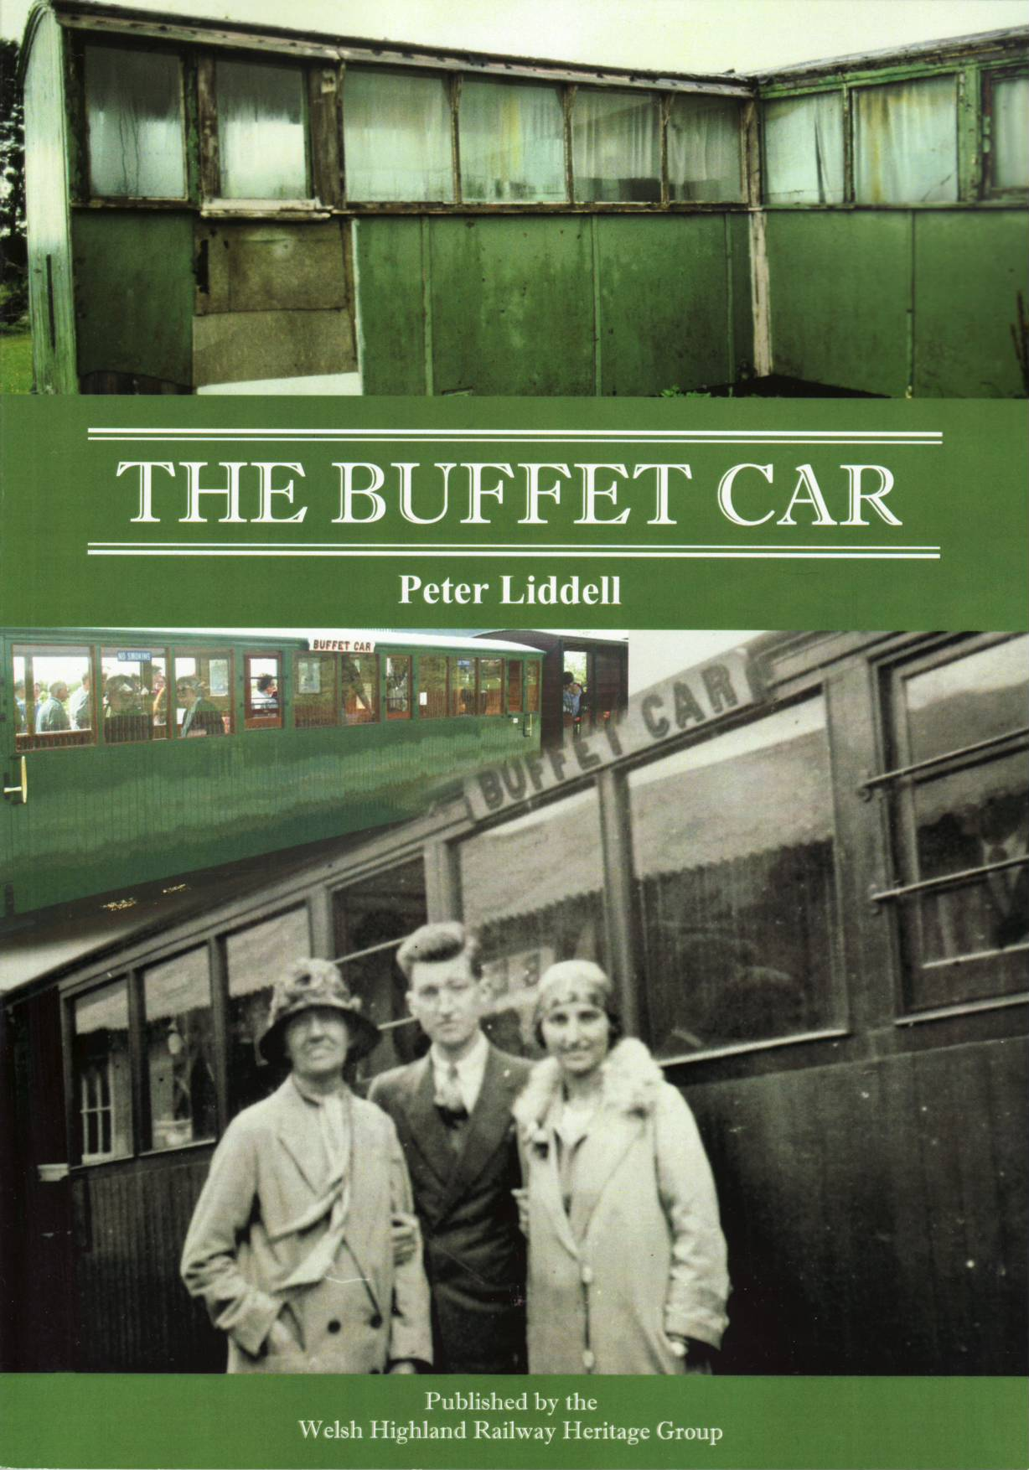
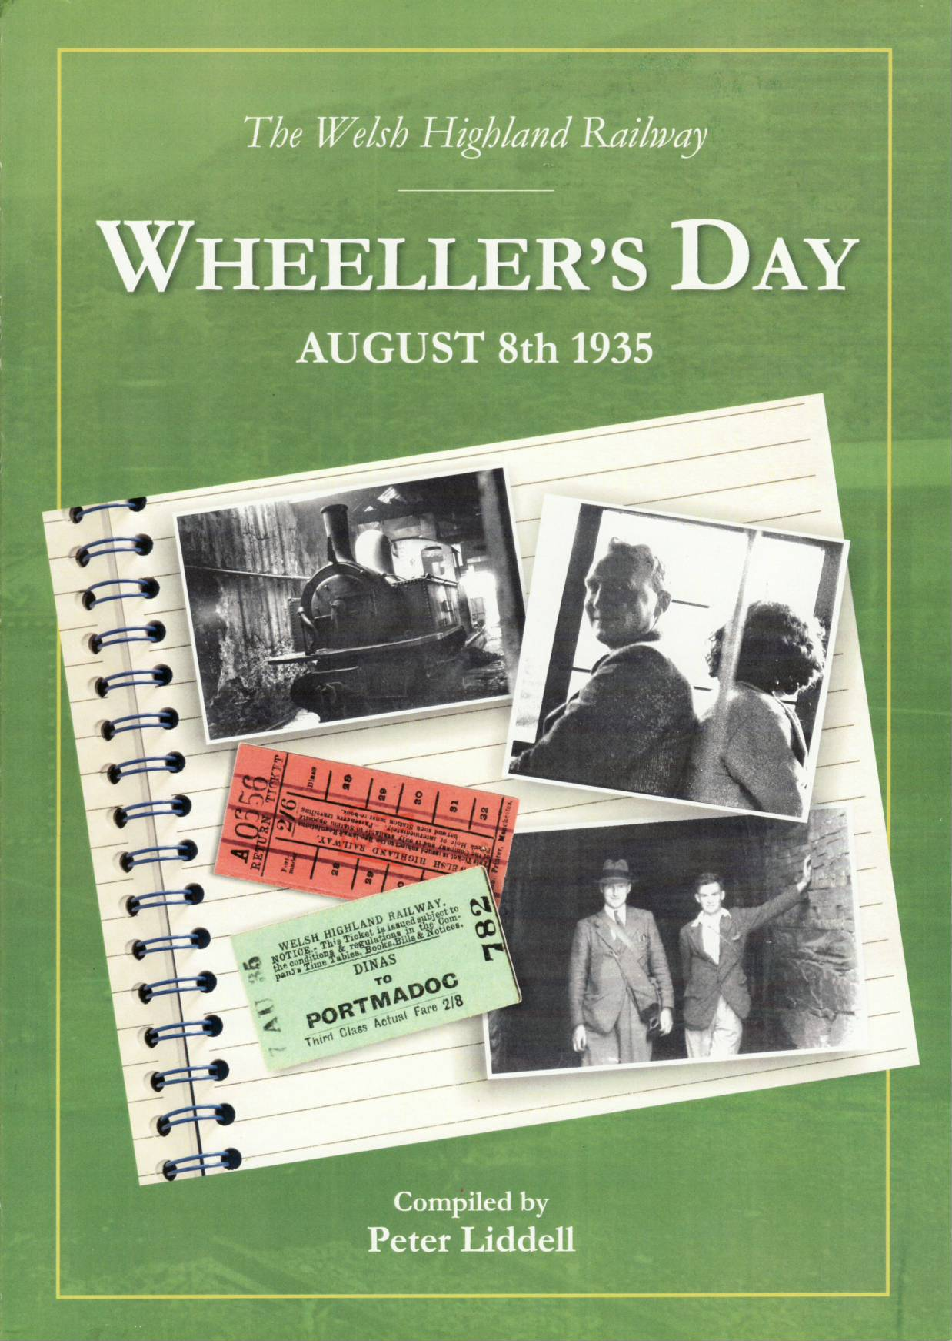 | Wheeler’s Day  Redesigned and revised second edition of this fascinating and informative photographic record  of a visit to the WHR on  August 8th 1935.  £18.00
Very limited stock remains of this successful card that supports the Tryfan Junction project.  £7.50 per pack of 5  First come, first served, please state your preference clearly. | 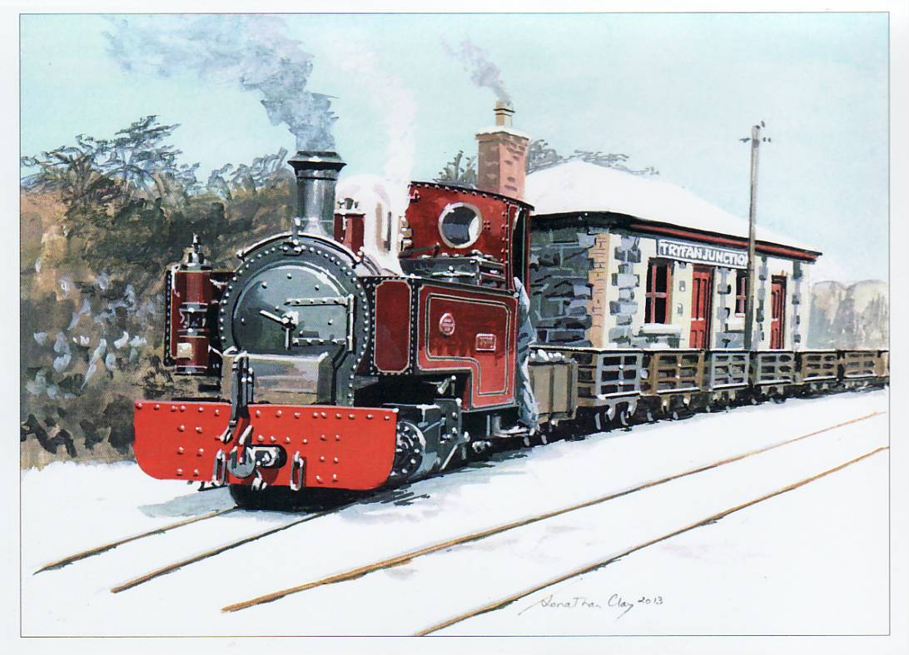
NWNGRys Ticket catalogue | £4.00 | Also available, all the old favourites. Stocks of some low and reprints may not be justified.  All orders despatched  POST FREE
Welsh Highland Rly ticket catalogue | £5.00
The Bryngwyn Branch | £15.00
Russell book | £4.95
WHHG Journal Index | £1.00
WHHG Journal Binder – single  - pair | £8.00  £15.00

WHHG Sales, 25 The Pound, Syresham, Brackley, Northants NN13 5HG
Cheques payable to Welsh Highland Heritage please.
www.welshhighlandheritage.co.uk

